


LAB WEEK 9
  - SEP 2026 SEMESTER

‘AFFAN NAJIY BIN RUSDI
22010453
BACHELOR OF COMPUTER SCIENCE
MODELING AND SIMULATION
TEB2103

Contents
Tasks 3
Task 1 3
Task 2 4
Task 3 5
Task 4 6
Task 5 7
Task 6 8
Task 7 9
Task 8 10
Task 9 11
Task 10 12

Tasks

Task 1
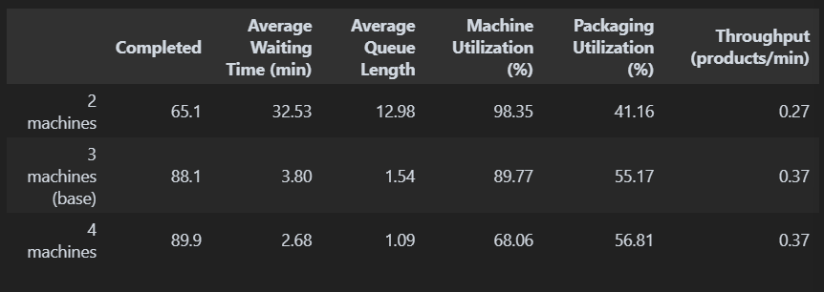

Explanation
Firstly, the factory was run with 2, 3 and 4 machines. Going from 2 to 4 machines raised completed products from 65.1 to 89.9 and cut the waiting time from 32.53 to 2.68 minutes, as 2 machines are 98% busy and cannot keep up. However, almost all of this gain comes from the third machine, since the fourth only adds 1.8 products and machine utilization drops to 68%. This is like opening a fourth checkout counter at a quiet supermarket, where the extra cashier mostly waits for customers.

Code
COLUMNS = ["Completed", "Average Waiting Time (min)", "Average Queue Length",
"Machine Utilization (%)", "Packaging Utilization (%)", "Throughput (products/min)"]
compare({"2 machines": {"machines": 2},
"3 machines (base)": {"machines": 3},
"4 machines": {"machines": 4}}, COLUMNS)

Task 2
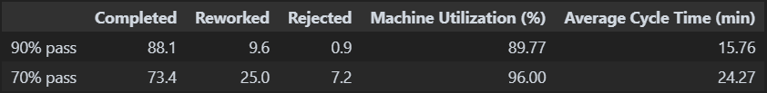

Explanation
Secondly, the pass probability was reduced from 90% to 70%. Reworked products went from 9.6 to 25.0 and rejected products from 0.9 to 7.2, since the chance of failing twice rose from 1% to 9%. As a result, completed products dropped from 88.1 to 73.4 and the cycle time rose from 15.8 to 24.3 minutes, because every rework uses the machine and inspector again. This is similar to students resitting an exam, where every resit takes a seat that a new student could have used.

Code
compare({"90% pass": {"pass_prob": 0.90},
"70% pass": {"pass_prob": 0.70}},
["Completed", "Reworked", "Rejected", "Machine Utilization (%)", "Average Cycle Time (min)"])

Task 3
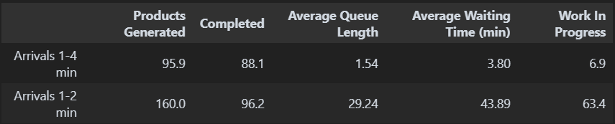

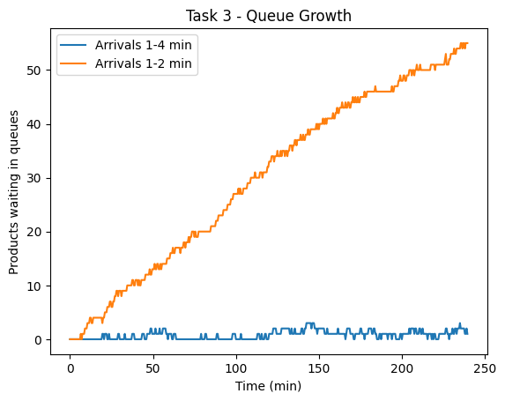
Explanation
Thirdly, the arrival time was changed from 1-4 to 1-2 minutes, so a product arrives every 1.5 minutes instead of 2.5. The factory received 160.0 products but only completed 96.2, since 3 machines can only finish about 0.5 products per minute. As a result, the queue grew from 1.54 to 29.24 products and the waiting time from 3.80 to 43.89 minutes. The graph shows the queue climbing in a straight line, which is like pouring water into a funnel faster than it can drain.

Code
compare({"Arrivals 1-4 min": {"arrival": (1, 4)},
"Arrivals 1-2 min": {"arrival": (1, 2)}},
["Products Generated", "Completed", "Average Queue Length",
"Average Waiting Time (min)", "Work In Progress"])

run_factory(seed=42)
plt.plot(queue_times, queue_sizes, label="Arrivals 1-4 min")
run_factory({"arrival": (1, 2)}, seed=42)
plt.plot(queue_times, queue_sizes, label="Arrivals 1-2 min")
plt.xlabel("Time (min)")
plt.ylabel("Products waiting in queues")
plt.title("Task 3 - Queue Growth")
plt.legend()
plt.show()

Task 4
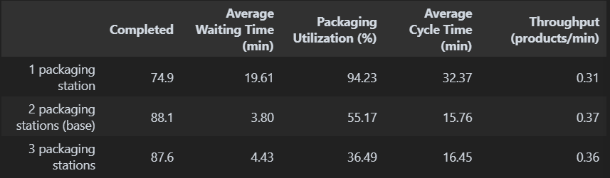

Explanation
Fourthly, the factory was run with 1, 2 and 3 packaging stations. Adding a third station did not help, as completed products stayed at about 88 and the stations were only 36% busy. However, with only 1 station, it was 94% busy, completed products dropped to 74.9 and the waiting time rose to 19.61 minutes. Hence, adding a station only helps where the line is stuck, similar to widening a road that has no traffic jam.

Code
compare({"1 packaging station": {"packers": 1},
"2 packaging stations (base)": {"packers": 2},
"3 packaging stations": {"packers": 3}},
["Completed", "Average Waiting Time (min)", "Packaging Utilization (%)",
"Average Cycle Time (min)", "Throughput (products/min)"])

Task 5
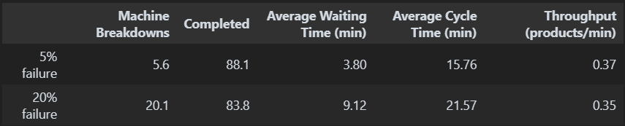

Explanation
Fifthly, the machine failure probability was raised from 5% to 20%, which increased breakdowns from 5.6 to 20.1 per run. Throughput dropped from 0.37 to 0.35 products per minute, and the waiting time more than doubled from 3.80 to 9.12 minutes. Machine utilization also went up from 90% to 95% (see the Task 9 table), but only because a broken machine still counts as busy while it waits for repair. This is like a lorry stuck at the workshop, which is "in use" but is not delivering anything.

Code
compare({"5% failure": {"fail_prob": 0.05},
"20% failure": {"fail_prob": 0.20}},
["Machine Breakdowns", "Completed", "Average Waiting Time (min)",
"Average Cycle Time (min)", "Throughput (products/min)"])

Task 6
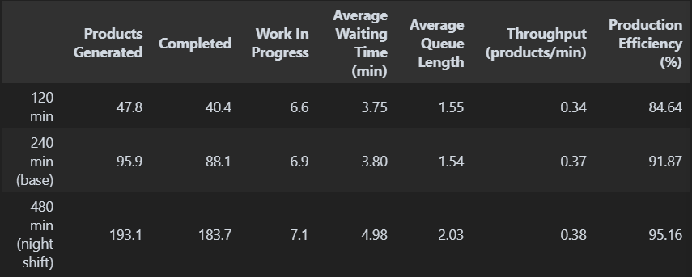

Explanation
Sixthly, the factory was run for 120, 240 and 480 minutes. The 480-minute night shift completed 183.7 products compared to 40.4 in 120 minutes, and throughput rose slightly from 0.34 to 0.38 products per minute. The waiting time stayed under 5 minutes in all three runs, which shows the queue does not keep growing over time. Efficiency also rose from 85% to 95%, as the few products left unfinished at the end matter less in a longer shift.

Code
compare({"120 min": {"sim_time": 120},
"240 min (base)": {"sim_time": 240},
"480 min (night shift)": {"sim_time": 480}},
["Products Generated", "Completed", "Work In Progress", "Average Waiting Time (min)",
"Average Queue Length", "Throughput (products/min)", "Production Efficiency (%)"])

Task 7
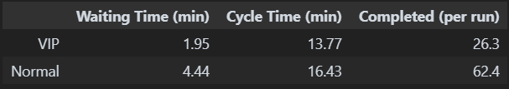

Explanation
Seventhly, 30% of products were made VIP, and each request now uses `priority=0` for VIP and `priority=1` for normal orders, where the smaller number is served first. VIP orders waited 1.95 minutes compared to 4.44 minutes for normal orders. The difference is small because the queues are already short, and total completed products stayed at about 89, since priority only changes the order, not the capacity. This is like priority boarding at the airport, where you board first but the plane still leaves at the same time.

Code
vip_wait, vip_cycle, normal_wait, normal_cycle = [], [], [], []
for seed in range(1, 11):
run_factory({"vip_prob": 0.30}, seed=seed)
for p in products:
if p["status"] == "Completed":
if p["vip"]:
vip_wait.append(p["wait"])
vip_cycle.append(p["end"] - p["arrival"])
else:
normal_wait.append(p["wait"])
normal_cycle.append(p["end"] - p["arrival"])

pd.DataFrame({
"Waiting Time (min)": [sum(vip_wait) / len(vip_wait), sum(normal_wait) / len(normal_wait)],
"Cycle Time (min)": [sum(vip_cycle) / len(vip_cycle), sum(normal_cycle) / len(normal_cycle)],
"Completed (per run)": [len(vip_wait) / 10, len(normal_wait) / 10],
}, index=["VIP", "Normal"]).round(2)

Task 8
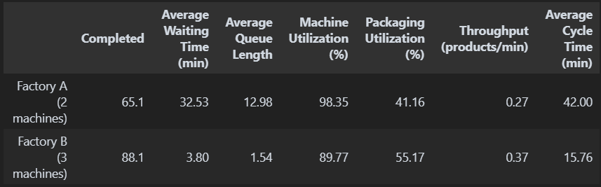
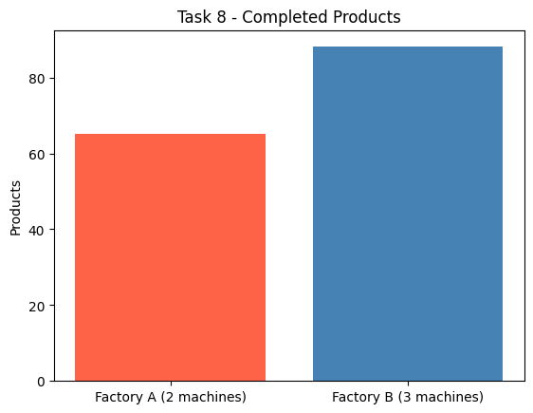

Explanation
Eighthly, Factory A with 2 machines, as in the lab sheet, was compared with Factory B with 3 machines, which is the base model. Factory B completed 88.1 products compared to 65.1, and cut the waiting time from 32.53 to 3.80 minutes. This is because Factory A can only finish 0.33 products per minute while 0.4 arrive, so its queue keeps growing. Hence, one extra machine gives 23 more products per shift.

Code
t8 = compare({"Factory A (2 machines)": {"machines": 2},
"Factory B (3 machines)": {"machines": 3}},
COLUMNS + ["Average Cycle Time (min)"])
display(t8)

plt.bar(t8.index, t8["Completed"], color=["tomato", "steelblue"])
plt.title("Task 8 - Completed Products")
plt.ylabel("Products")
plt.show()

Task 9
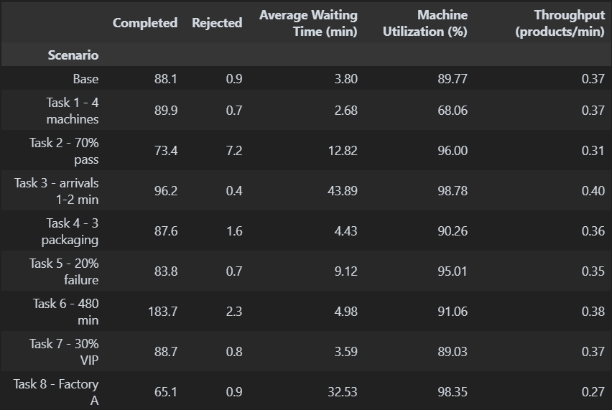

Explanation
Ninthly, every scenario from Tasks 1-8 was run 10 times, and the averages were saved to `production_report.csv` using `to_csv()`, with one row per scenario. A second file, `production_log.csv`, stores one row per product from the base run. Both files can be opened in Excel, so the results can be checked without running the code again.

Code
scenarios = {
"Base": {},
"Task 1 - 4 machines": {"machines": 4},
"Task 2 - 70% pass": {"pass_prob": 0.70},
"Task 3 - arrivals 1-2 min": {"arrival": (1, 2)},
"Task 4 - 3 packaging": {"packers": 3},
"Task 5 - 20% failure": {"fail_prob": 0.20},
"Task 6 - 480 min": {"sim_time": 480},
"Task 7 - 30% VIP": {"vip_prob": 0.30},
"Task 8 - Factory A": {"machines": 2},
}
rows = []
for name in scenarios:
rows.append(run_many(scenarios[name]))
report = pd.DataFrame(rows, index=list(scenarios)).round(2)
report.index.name = "Scenario"
report.to_csv("production_report.csv")

run_factory(seed=42) # product-by-product log of the base run
pd.DataFrame(products).to_csv("production_log.csv", index=False)

print("Saved production_report.csv and production_log.csv")
report[["Completed", "Rejected", "Average Waiting Time (min)",
"Machine Utilization (%)", "Throughput (products/min)"]]

Task 10
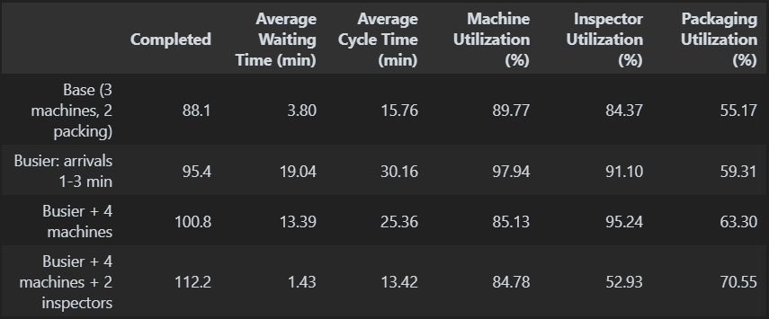

Explanation
Lastly, the base factory with 3 machines and 2 packaging stations is well balanced, as it completes 92% of its products with only a 3.80 minute wait. The machines (90%) and the inspector (84%) are the busiest stations, which is why adding a fourth machine or a third packaging station barely helps, while removing one makes the queue grow quickly.

Quality and breakdowns also reduce output, as a 70% pass rate cost 14.7 products and a 20% failure rate cost 4.3 products, because reworks and repairs take up machine time. On the other hand, VIP orders and longer shifts do not add capacity, they only change who goes first or how long the factory runs.

The table below makes the factory busier, with a product every 2 minutes. The machines become the bottleneck at 98%, and after a fourth machine is added, the inspector becomes the new bottleneck at 95%. Only after a second inspector is added does the waiting time drop to 1.43 minutes. Hence, a production line is only as fast as its slowest station, so the slowest station should always be improved first.

Code
compare({"Base (3 machines, 2 packing)": {},
"Busier: arrivals 1-3 min": {"arrival": (1, 3)},
"Busier + 4 machines": {"arrival": (1, 3), "machines": 4},
"Busier + 4 machines + 2 inspectors": {"arrival": (1, 3), "machines": 4, "inspectors": 2}},
["Completed", "Average Waiting Time (min)", "Average Cycle Time (min)",
"Machine Utilization (%)", "Inspector Utilization (%)", "Packaging Utilization (%)"])



